Title: Who’S The Alien |  | Type: Required #13
Name: | Rank: | Department:
Passed By: | Date Passed: / / | Credit towards rank:

From the pictures identify the character, their race, and the actor.
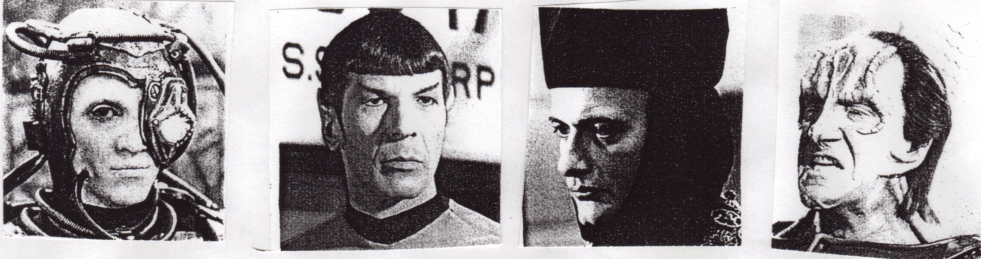
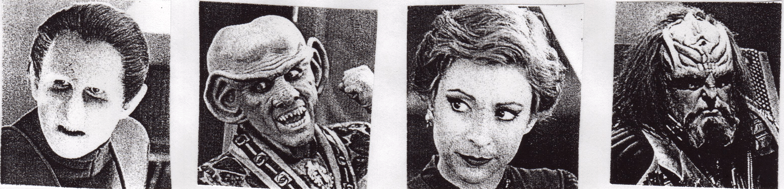
1. 2. 3. 4.

5. 6. 7. 8.

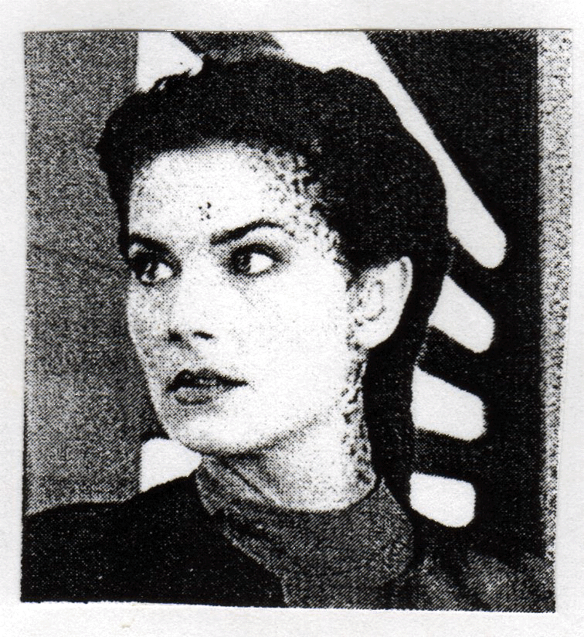
9.

PMP’s: 4 Knowledge

