Title: Lower Decks (VOY) |  | Type: Merit Sheet Actors #6
Name: | Rank: | Department:
Passed By: | Date Passed: / / | Credit towards rank:

How Well Do You Know Your Minor U.S.S. Voyager Crewmembers? Identify the character from the picture.

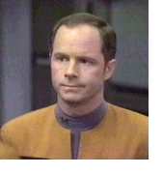1. ____________________ 8. ____________________

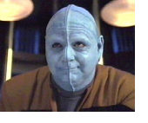2. ____________________ 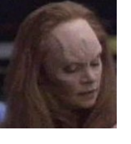9. ____________________

3. ____________________ 10. ___________________

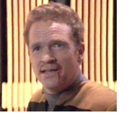4. ____________________ 11. ____________________

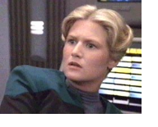5. ____________________ 12. ____________________

6. ____________________ 13. ____________________
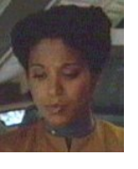

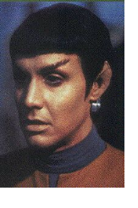
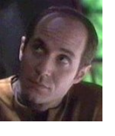7. ____________________

14. ____________________

PMP’s: 4 knowledge

(NOTE: A color Master Sheet is available for review)

